KITCHENSYNC

# Deployment Manual

table contents

1. Introduction
2. System Requirements
3. Software Requirements
4. Installation of Applications

* Installing Python
* Installing Anaconda
* Installing Visual Studio Code (VSCode)
* Installing Chrome

1. Clone Our GitHub Repository
2. Starting the server
3. Running the Application
4. Results
5. GitHub Wiki
6. INTRODUCTION

Welcome to the Deployment Manual of the KitchenSync Application. This document will provide you with a step-by-step guide for the effective installation of our Software on your system or in your Environment.

**Project Overview**

KitchenSync is designed for busy individuals, families, and small firms that struggle to keep their pantries organized and cut down on food waste.

KitchenSync Streamlines your pantry management and meal planning Seamlessly. It is a sophisticated kitchen assistance platform, that enhances the management of your pantry and offers recipe options that fit your available ingredients, organizes meal plans, and reminds you of the shelf-life of your food items.

Unlike other traditional inventory systems and shopping list apps, KitchenSync adjusts to your dietary preferences and schedules by making use of readily available ingredients to simplify the meal preparation process.

**Technology Stack**

* Framework: Java Script
* Backend: JavaScript, Flask
* Database: SQLite
* Version Control: Anaconda
* Code Editor: Visual Studio Code

1. SYSTEM REQUIREMENTS

**Hardware requirements (Desktop)**

1. **Processor (CPU):**

Equivalent to AMD Ryzen 3 2.4Ghz (4-core)/

Intel Core i-3 2.6Ghz(4-core physical)/

Apple M1 (8-core)

1. **Memory (RAM):**

A minimum of 8 Gb DDR4 @ 4200 Mhz

1. **Storage:**

5 Gb of SSD space or equivalent for optimal performance

1. **GPU:**

Intel Iris Xe with 1.30 Ghz/ Radeon Graphics 2.00 Ghz

1. **Network Connectivity:**

Minimum download speed of 1Mpbs

1. **SOFTWARE REQUIREMENTS**
2. Operating System (windows)

Windows 8/10/11

1. Operating System (Mac)

MacOS Monterey / Big Sur / Catalina/Mojave

1. Operating System (Linux)

Ubuntu Jammy Jellyfish / Mantic Minotaur

1. Other Requirement: Latest Chrome version
2. INSTALLATION OF APPLICATIONS
3. **Installing Python**

The first and foremost step is to install Python on your local machine or your systems using the Link Below.

Python Installer: <https://www.python.org/downloads/>

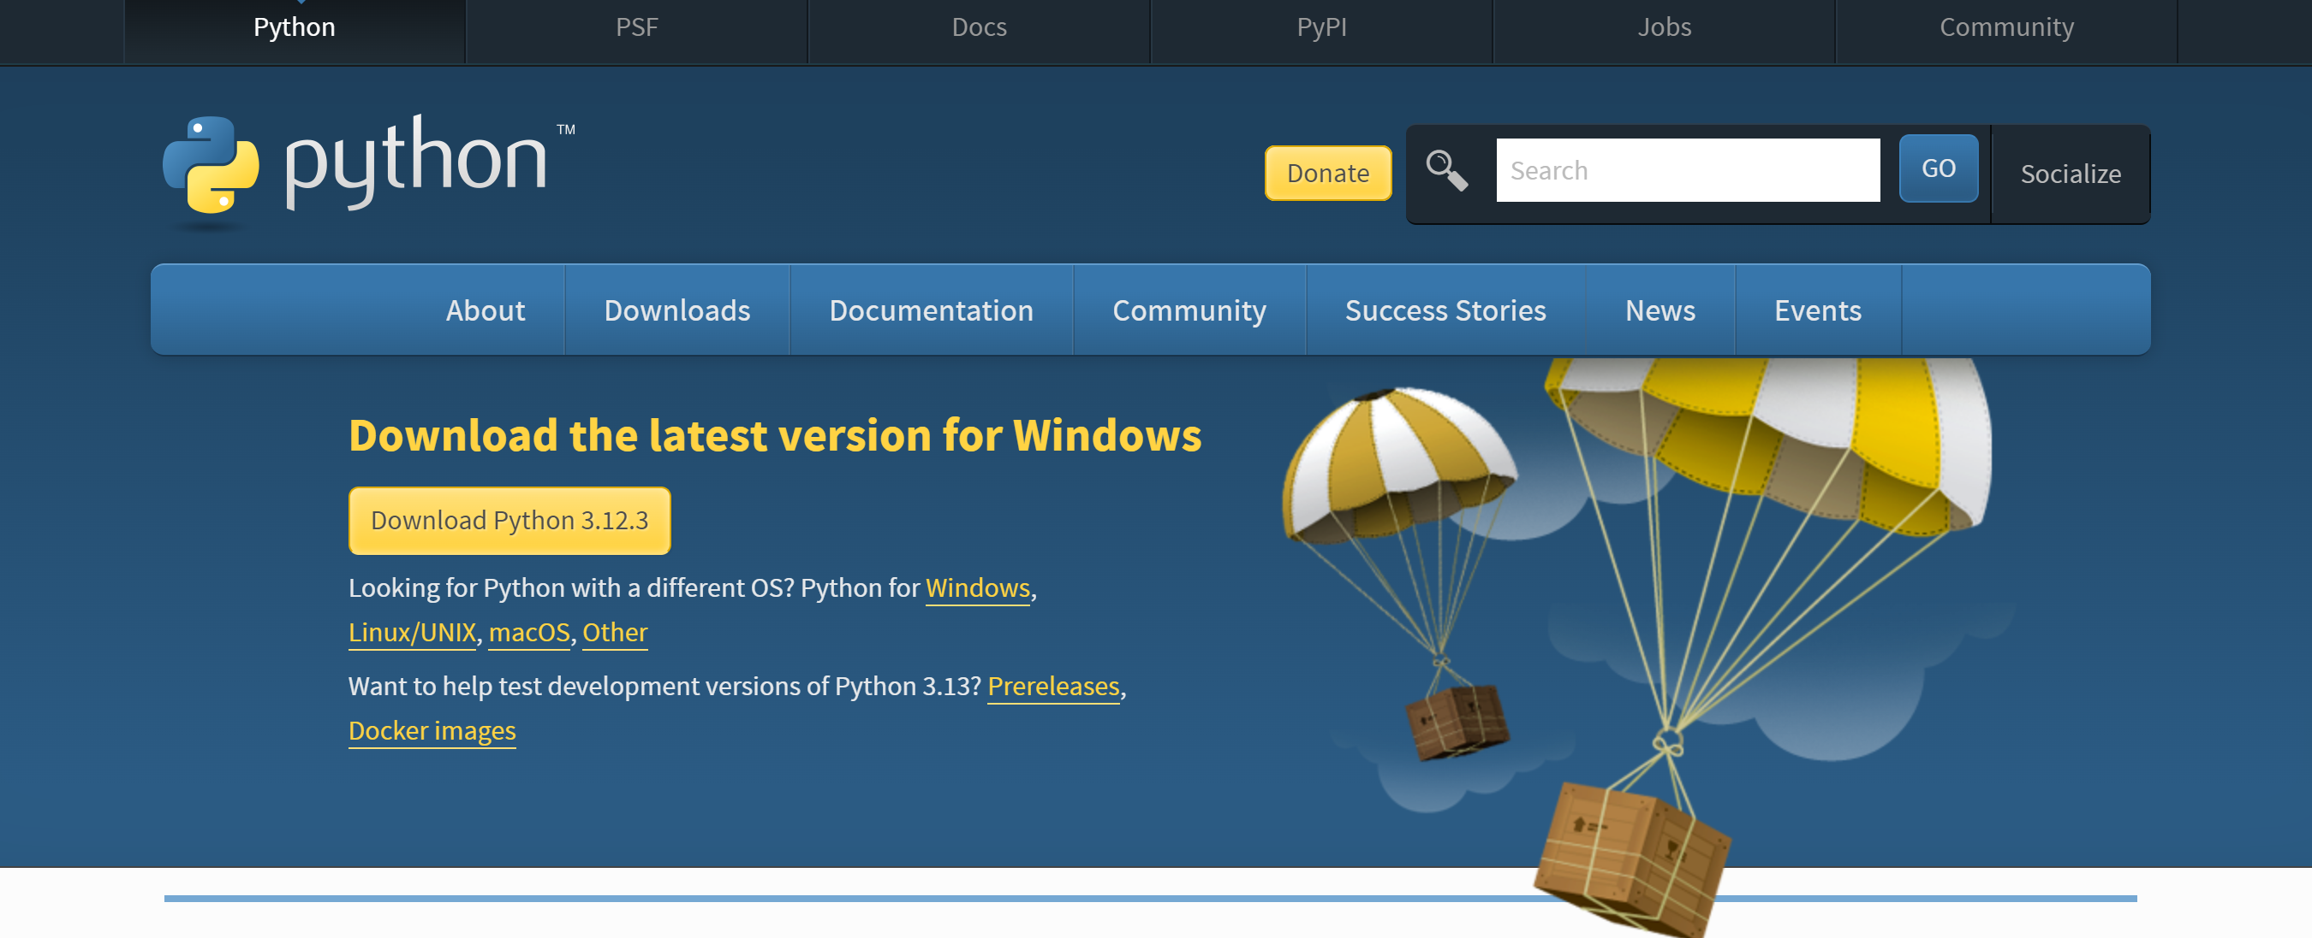

* You need to Download the Latest Version of Python by clicking the button Available there in Your Systems (Windows/Mac/Linux)
* Then you will see this pop-up with two options. Click the checkbox below (Add Python to PATH) and install Python in your system with your desired path(files in your system).

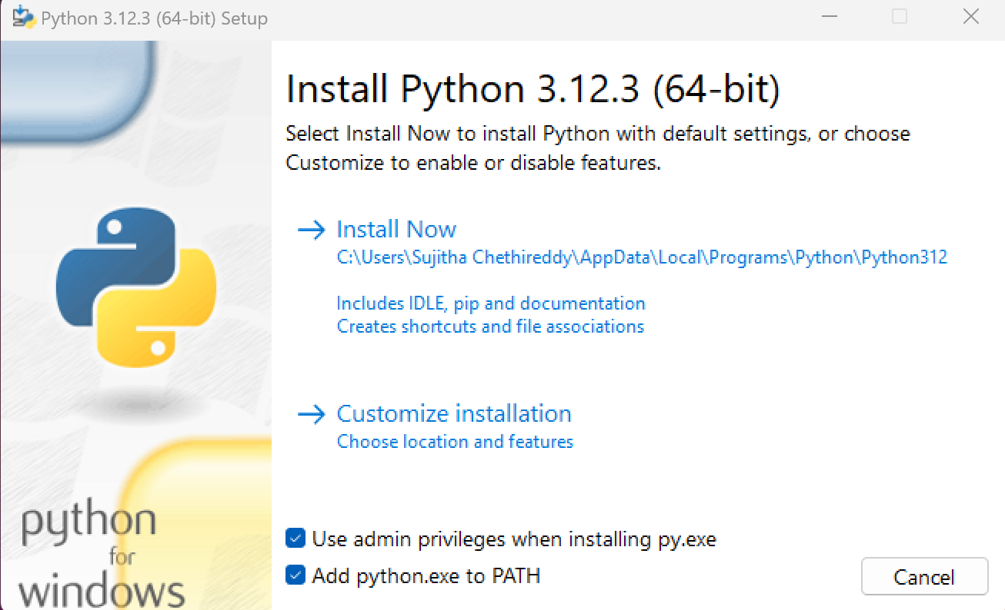

* Then click Install Now And you will see this pop-up.

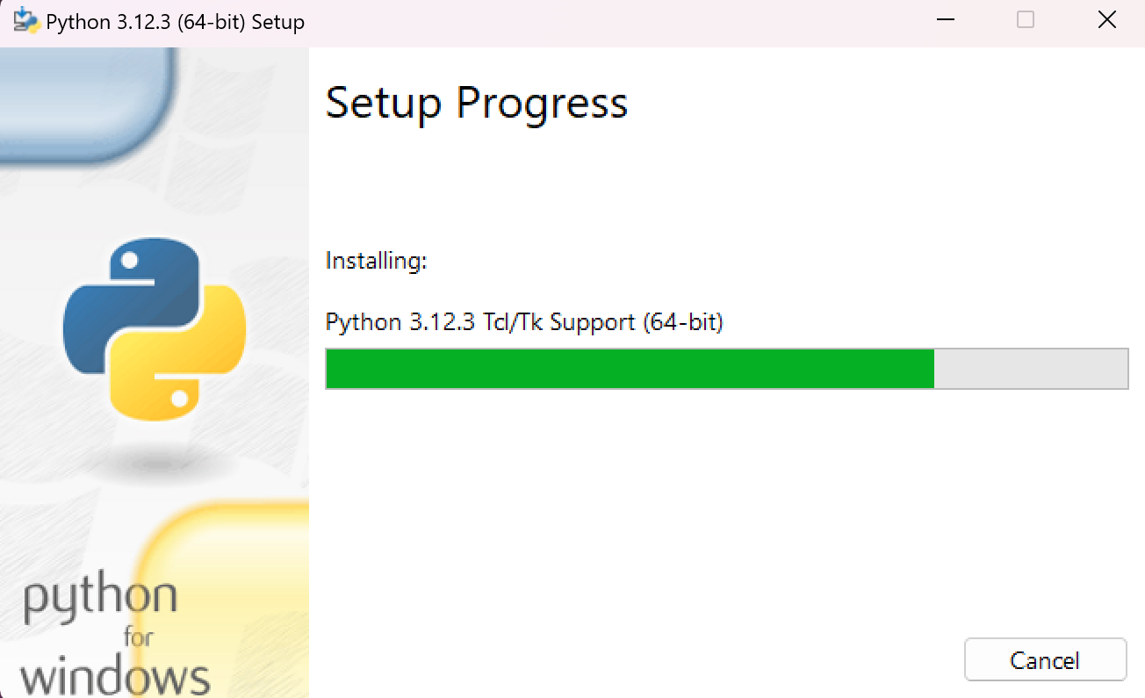

* After that Python is successfully downloaded to your system. Now double click on Python application and run it.

1. **Installing Anaconda**

The next important step is installing Anaconda to your System or your Local Machine

Anaconda Installer: <https://www.anaconda.com/download>

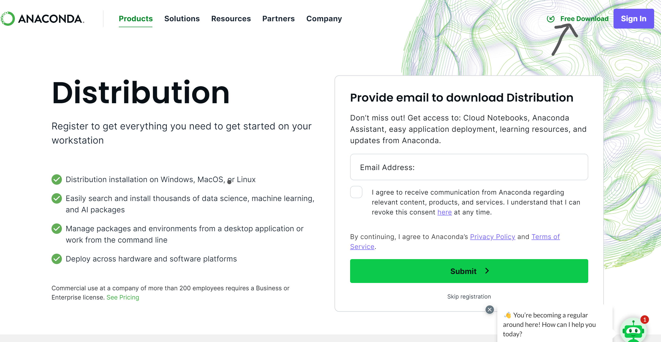

* After Clicking the link you will see this screen, click skip registration.

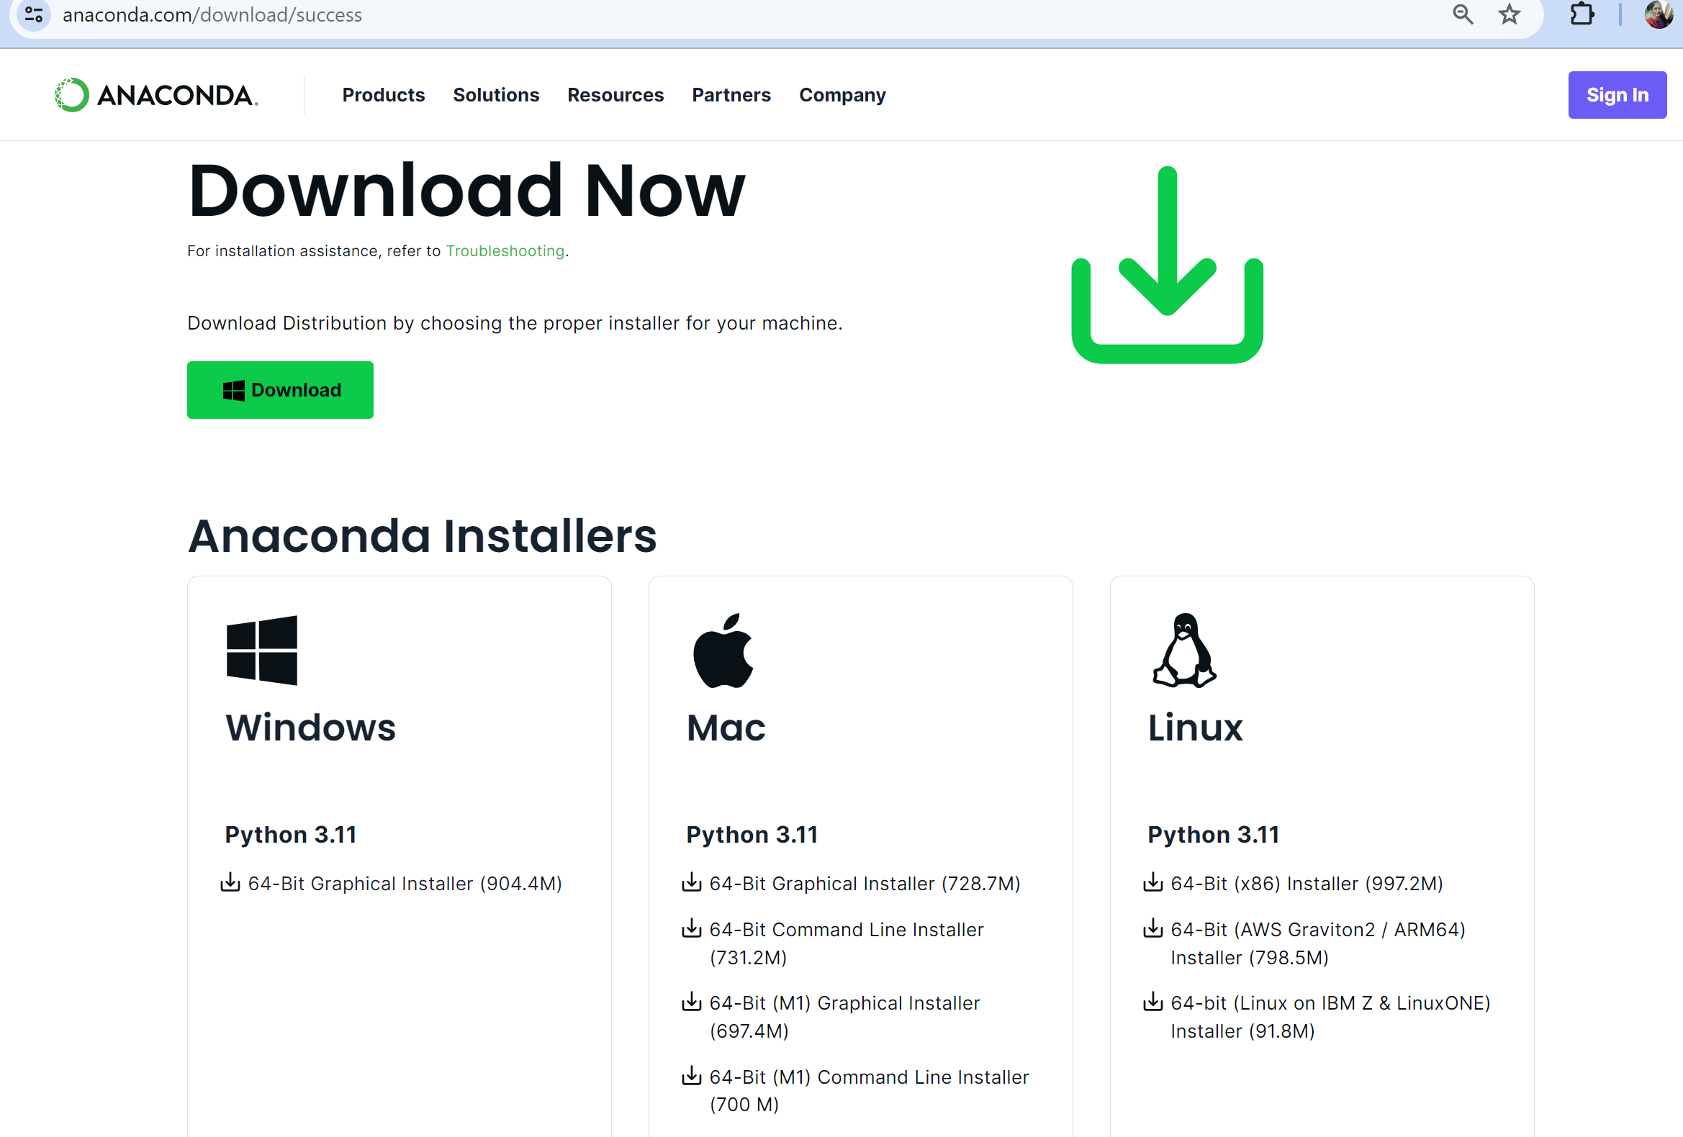

* Then you will see the Above page, Now Click “Download” Button on Anaconda Installer for your Operating system (Windows / Mac / Linux)
* Python is modified to the Necessary version from the Anaconda installer.

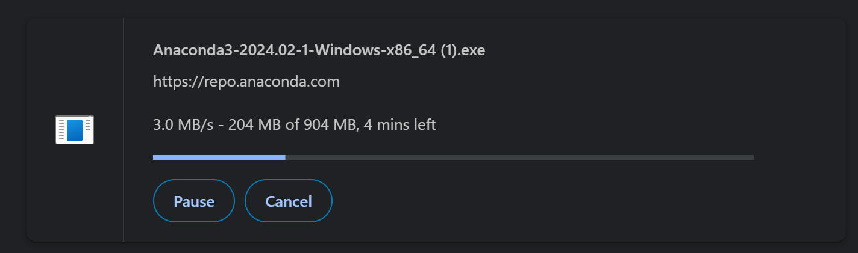

* Double click on the above .exe file after downloading it.

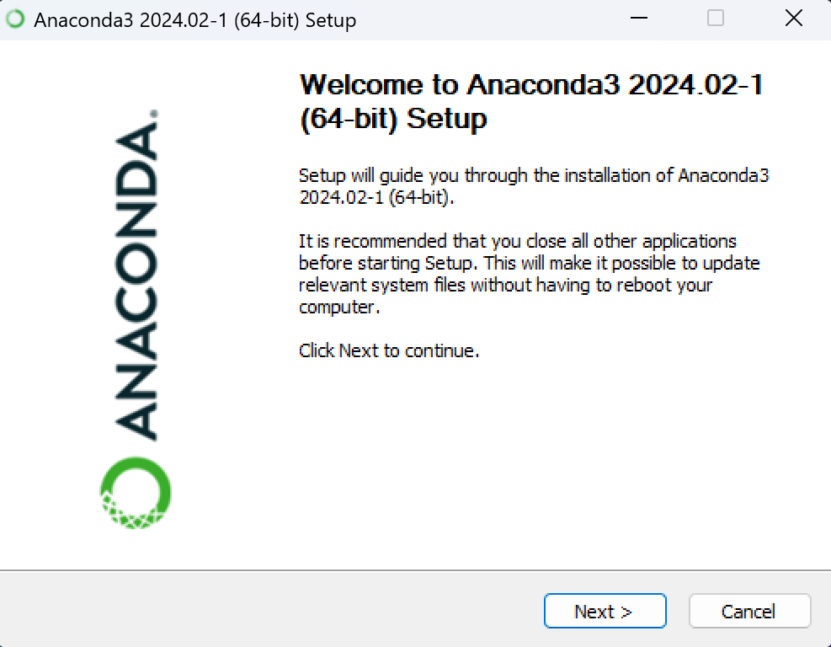

* You get this pop up, click Next and Then Agree to License page which comes next.
* Then will You get pop for type of installation you would like to perform Anaconda Install for Just Me or All Users. Select ‘Just Me’ option.
* Then you will see below pop up, now give your desired file path / location to install and Click Next.

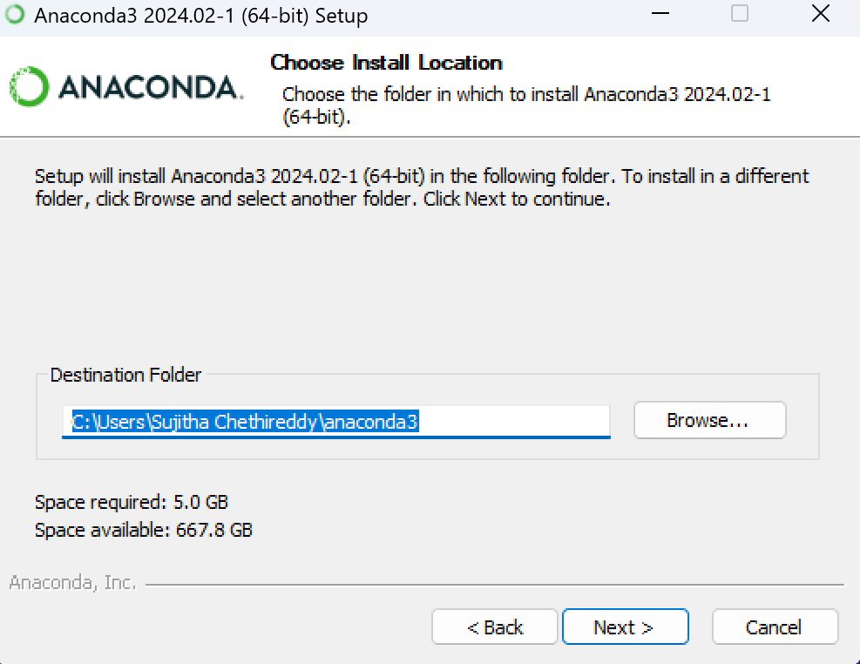

* After That Anaconda is installed in your system. You can open Anaconda prompt shell and run your commands.

1. **Installing Visual Studio Code (VS Code):**

The next step is to Download and install Visual Studio Code to your environment.

Download VS Code:

* Visit the official Visual Studio Code website at

<https://code.visualstudio.com/>

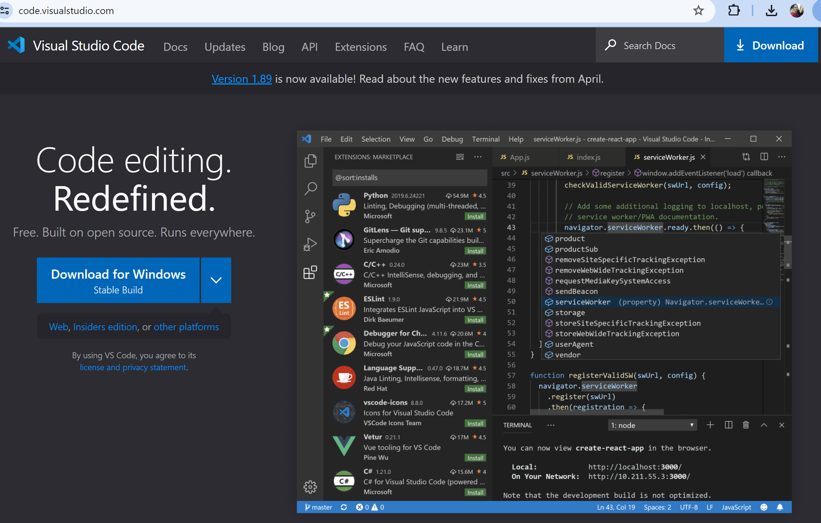

o Click on the "Download" button to download the installer for your

operating system (e.g., Windows, macOS, or Linux).

Install VS Code:

* Once the installer is downloaded, run the installer executable.
* Follow the on-screen instructions to install VS Code, including accepting the license agreement. (same as the above installations)
* Choose your preferred installation settings and location (you can usually leave the default settings as they are).

Launch VS Code:

* After installation, you can launch VS Code from your system's application

menu or desktop shortcut.

1. **Installing Chrome**

The next step is Downloading the Chrome Browser in your system (it makes running of application easy)

* For Mac OS or Windows: Visit the official website using any web browser.

[google.com/chrome/](https://www.google.com/chrome/).

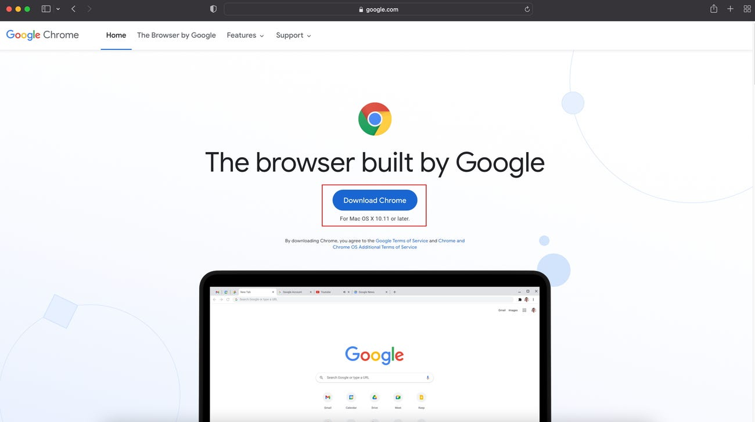

* Once there Click on the “Download Chrome" button, chrome start downloading in your system.

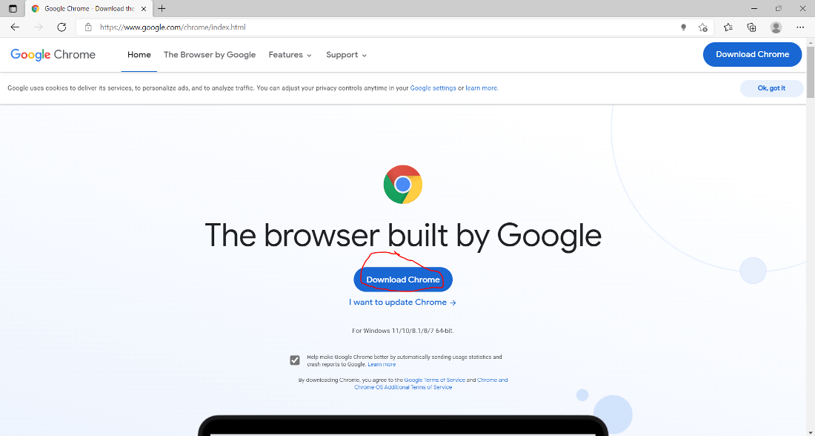

* Now the dialogue box will open then click on Accept and Install. Then you will find the executable file in the downloads folder in your system and run it.
* It will prompt confirmation to make changes to your system. Click on Yes. After this the installation process will start and will take 5 – 7 minutes depending on your Internet speed to complete the installation.

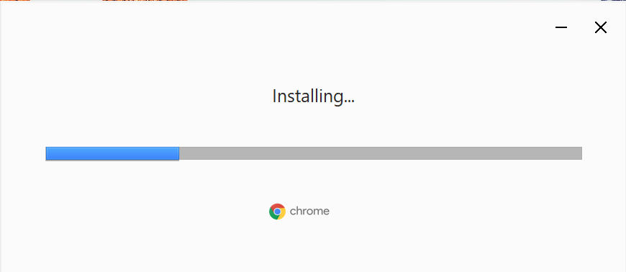

* After downloading it automatically, the Google Chrome browser will open. Be sure to sign in to your Google account so your content can start automatically syncing across devices.

1. CLONE OUR GITHUB REPOSITORY

**Open a Terminal or Command Prompt:**

* On your local computer, open a terminal (Linux/macOS) or a command prompt (Windows). You'll use this to run Git commands.

**Navigate to the Directory Where You Want to Clone the Repository:**

* Use the cd (change directory) command to navigate to the location (desired file path) where you want to clone the repository. For example, to clone the repository in your home directory.

**Clone the Repository:**

* Use the git clone command followed by the GitHub repository. GitHub repository command will be:

<https://github.com/htmw/2024S-neon-nomads.git>

* Users can either clone our repository by using the above link or download a ZIP of our application. To Download the ZIP, the user has to click on the “Download ZIP” button as shown below. It will download in the user’s specified location. After that, the user has to extract that ZIP.

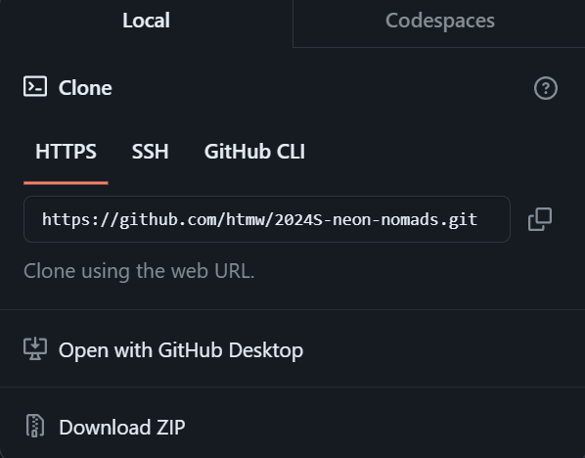

* Once it is Cloned in your location pull our project from the below link or download that zip file and extract it in your specific location.

<https://github.com/shashank-sde/Capstonekitchensync>

* Go to the folder where you extracted the code.
* Open the Anaconda PowerShell prompt now.
* Copy that file path/ location where you extracted the code, use the cd command, and paste the location of it in the PowerShell prompt.

cd C:\ user\Sujitha Chethireddy\Desktop\project\Capstonekitchensync (Don’t copy this use your own file path/ location)

1. STARTING THE SEVER

**Now follow the below commands step by step:**

* conda create -n "reciperecognizer" python=3.10
* conda activate reciperecognizer
* pip install -r requirements.txt
* Now you will see this screen like this:

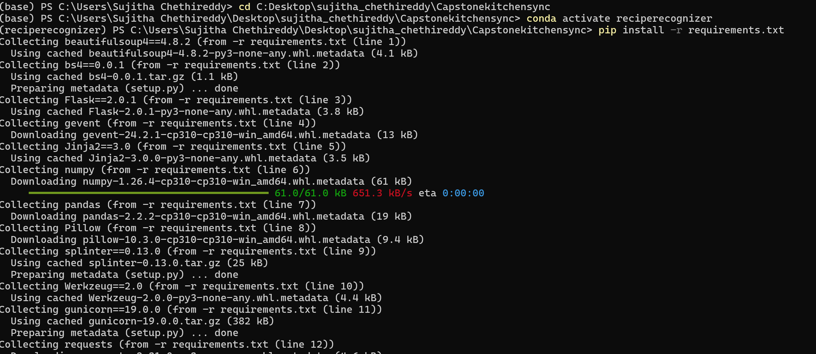

* Then you will see the following on the PowerShell prompt

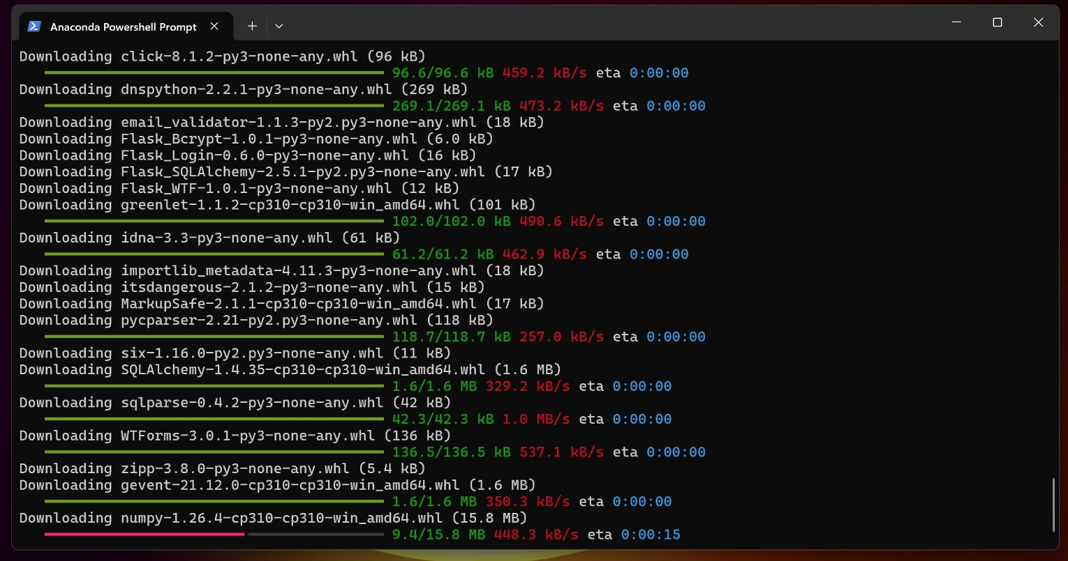

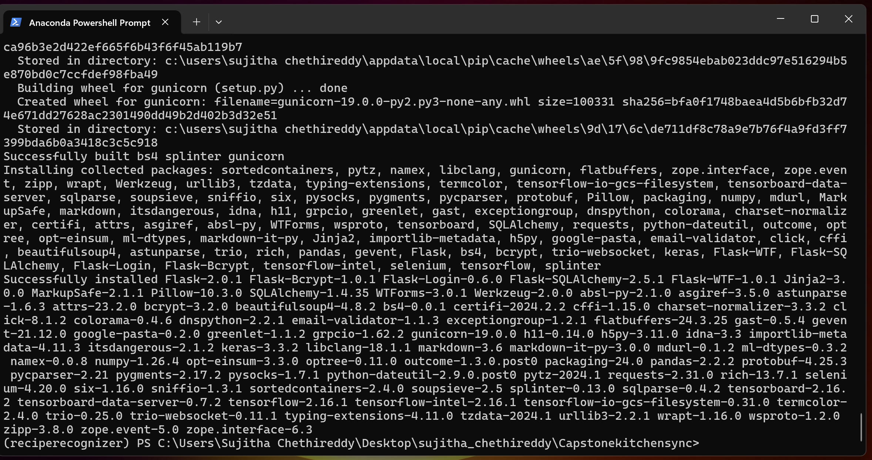

* pip install flask-migrate

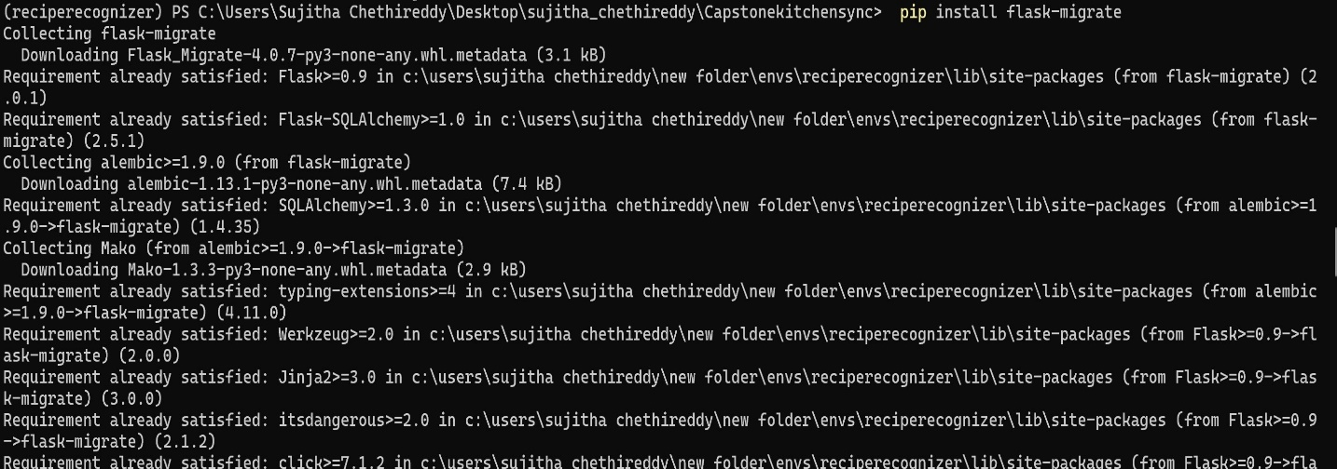

* python app.py

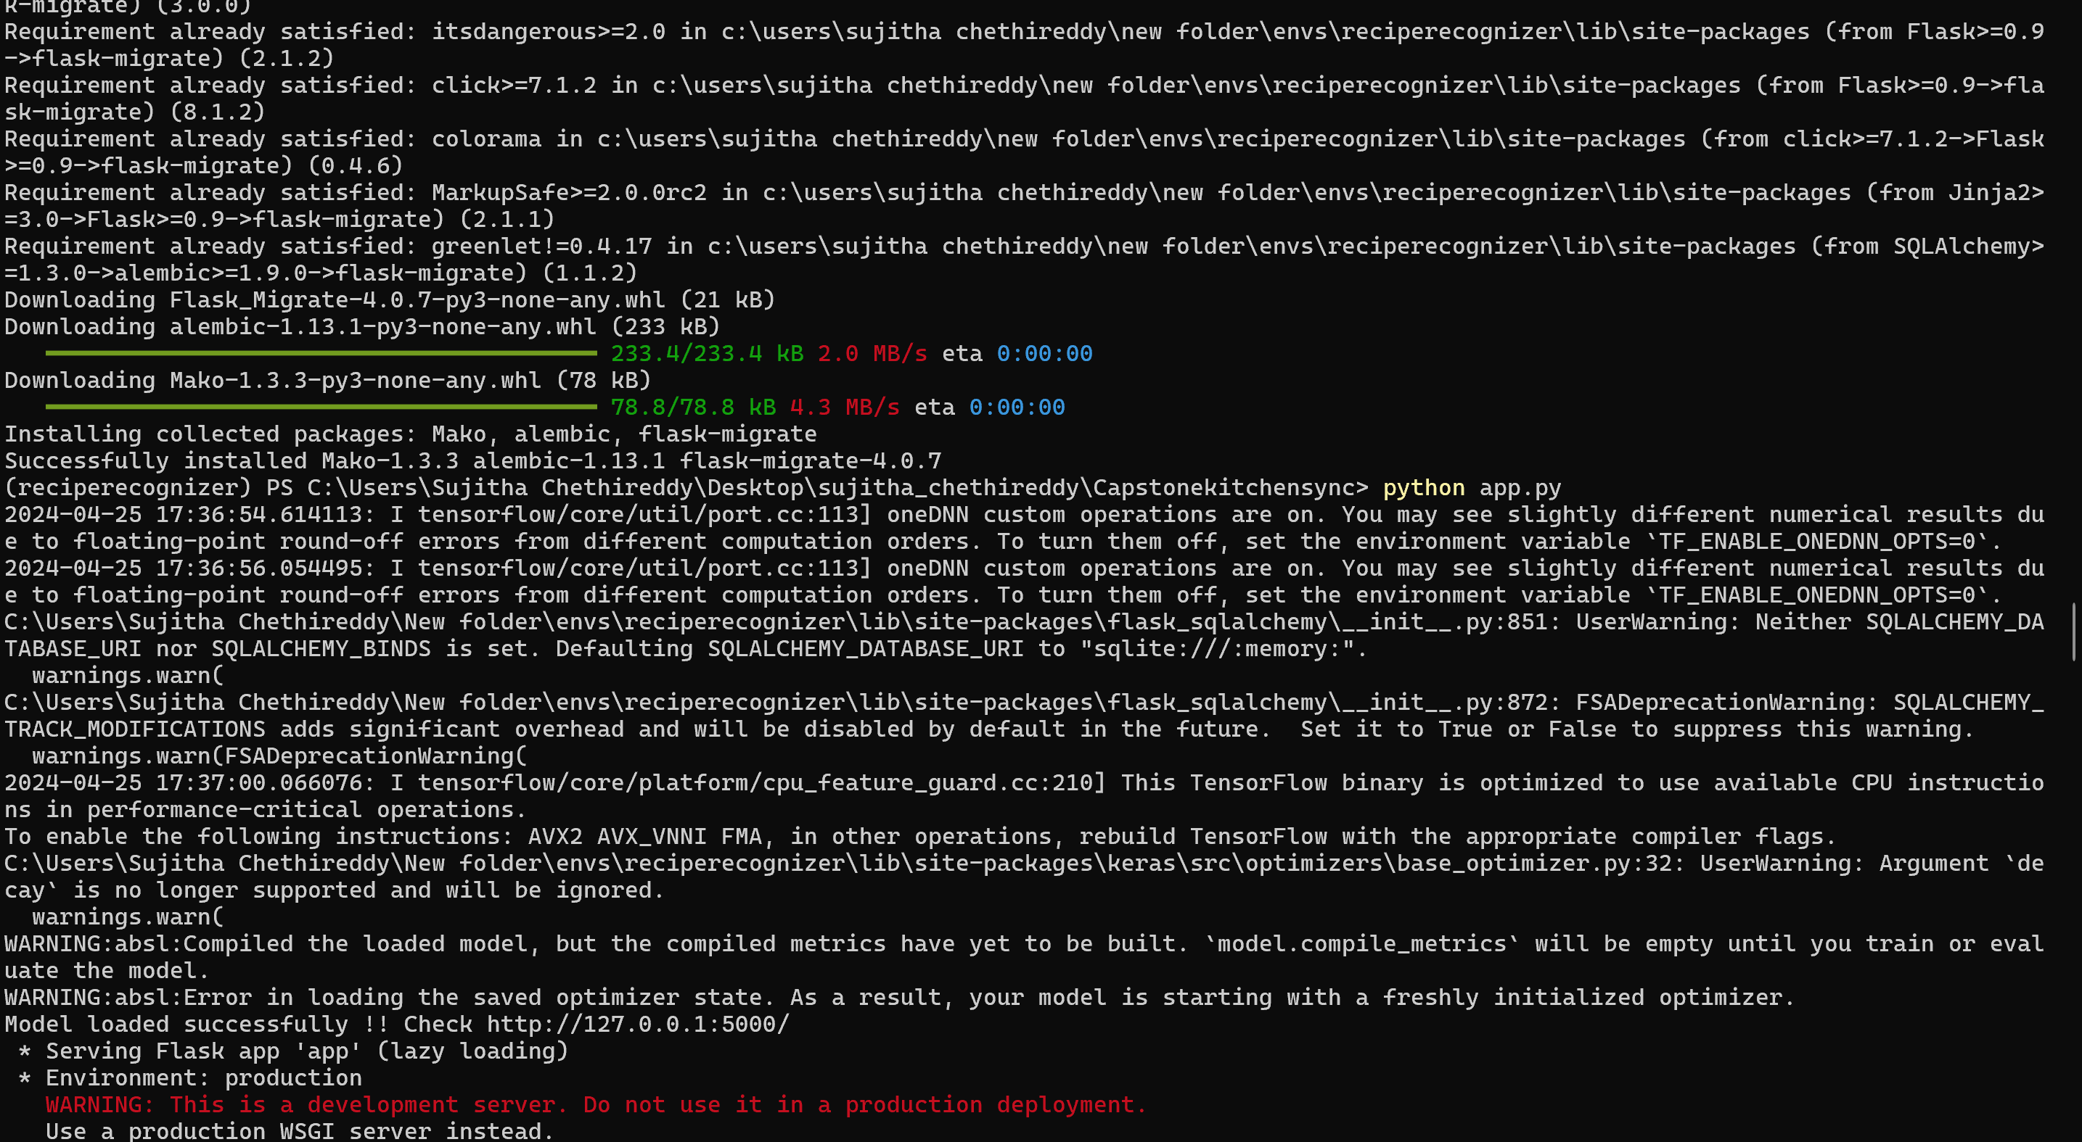

1. RUNNING THE APPLICATION

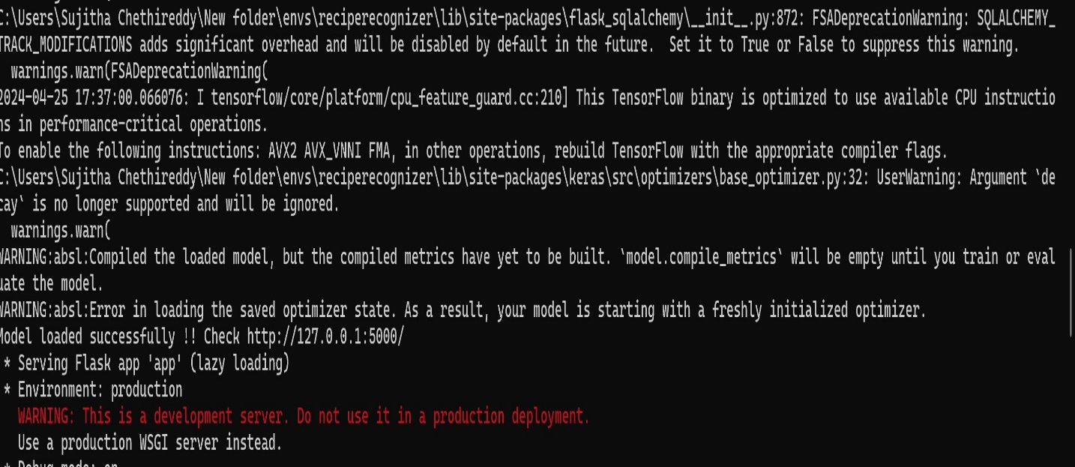

* Then its shows loaded Successfully and give check ‘Link’
* Now open Chrome Browser and paste the Link:

<http://127.0.0.1:5000/>

* Enter the URL box of Chrome Brower and hit the enter key. Now User can run our application.

1. RESULTS

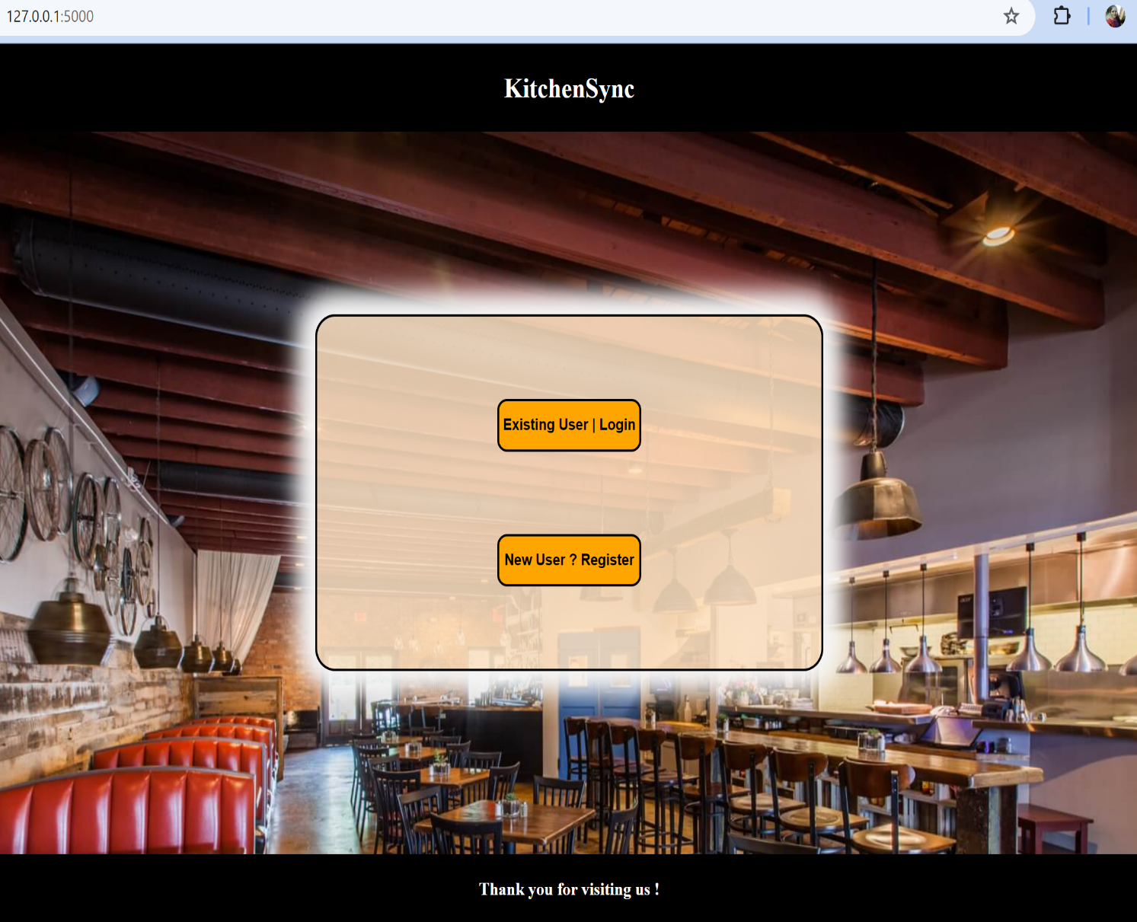

* You will get this screen when you run the application.

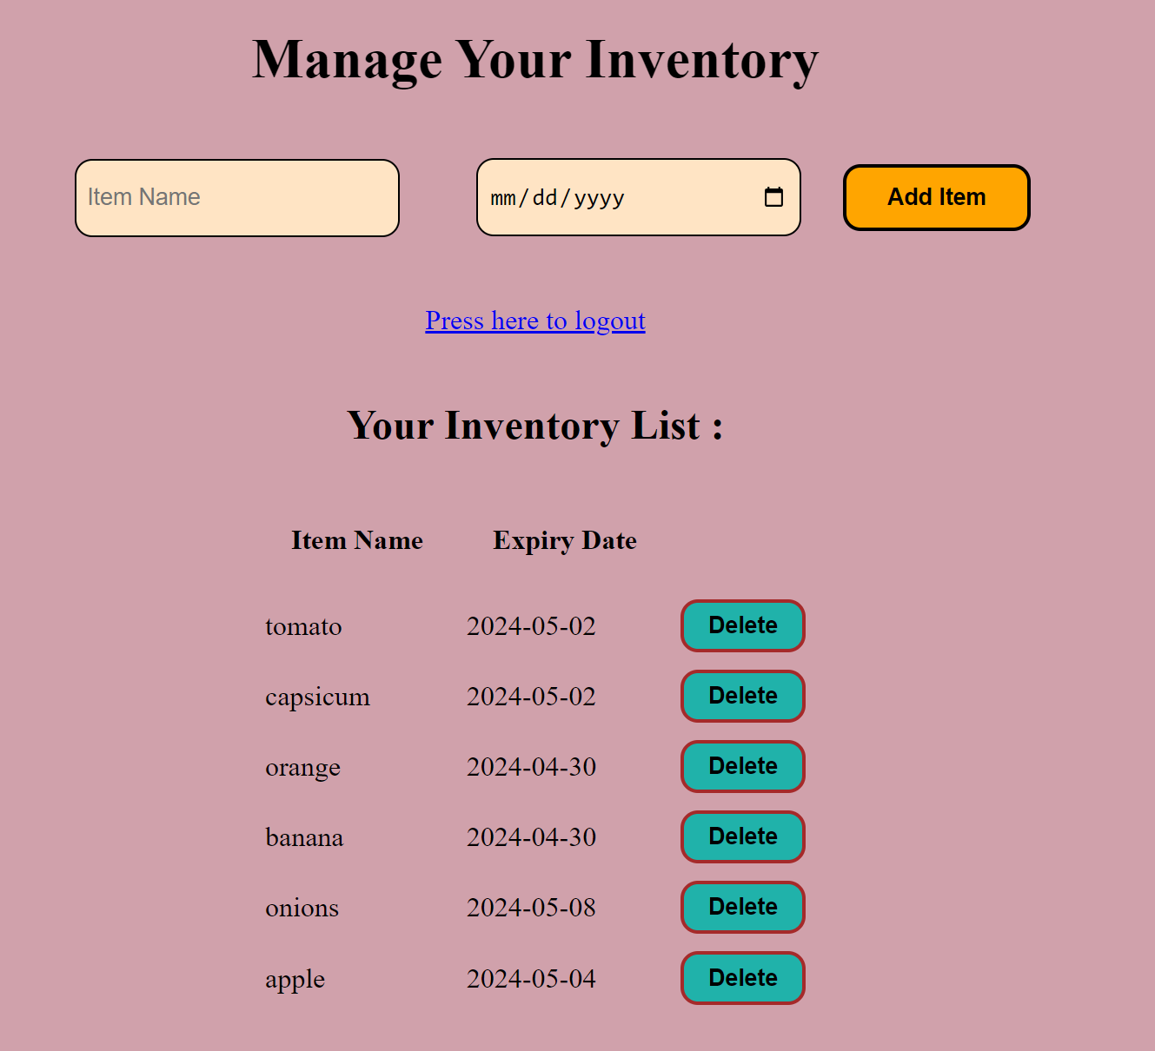

* This is how User’s Inventory List will be after they enter their Pantry Items and its Expiry Dates.

1. GITHUB WIKI

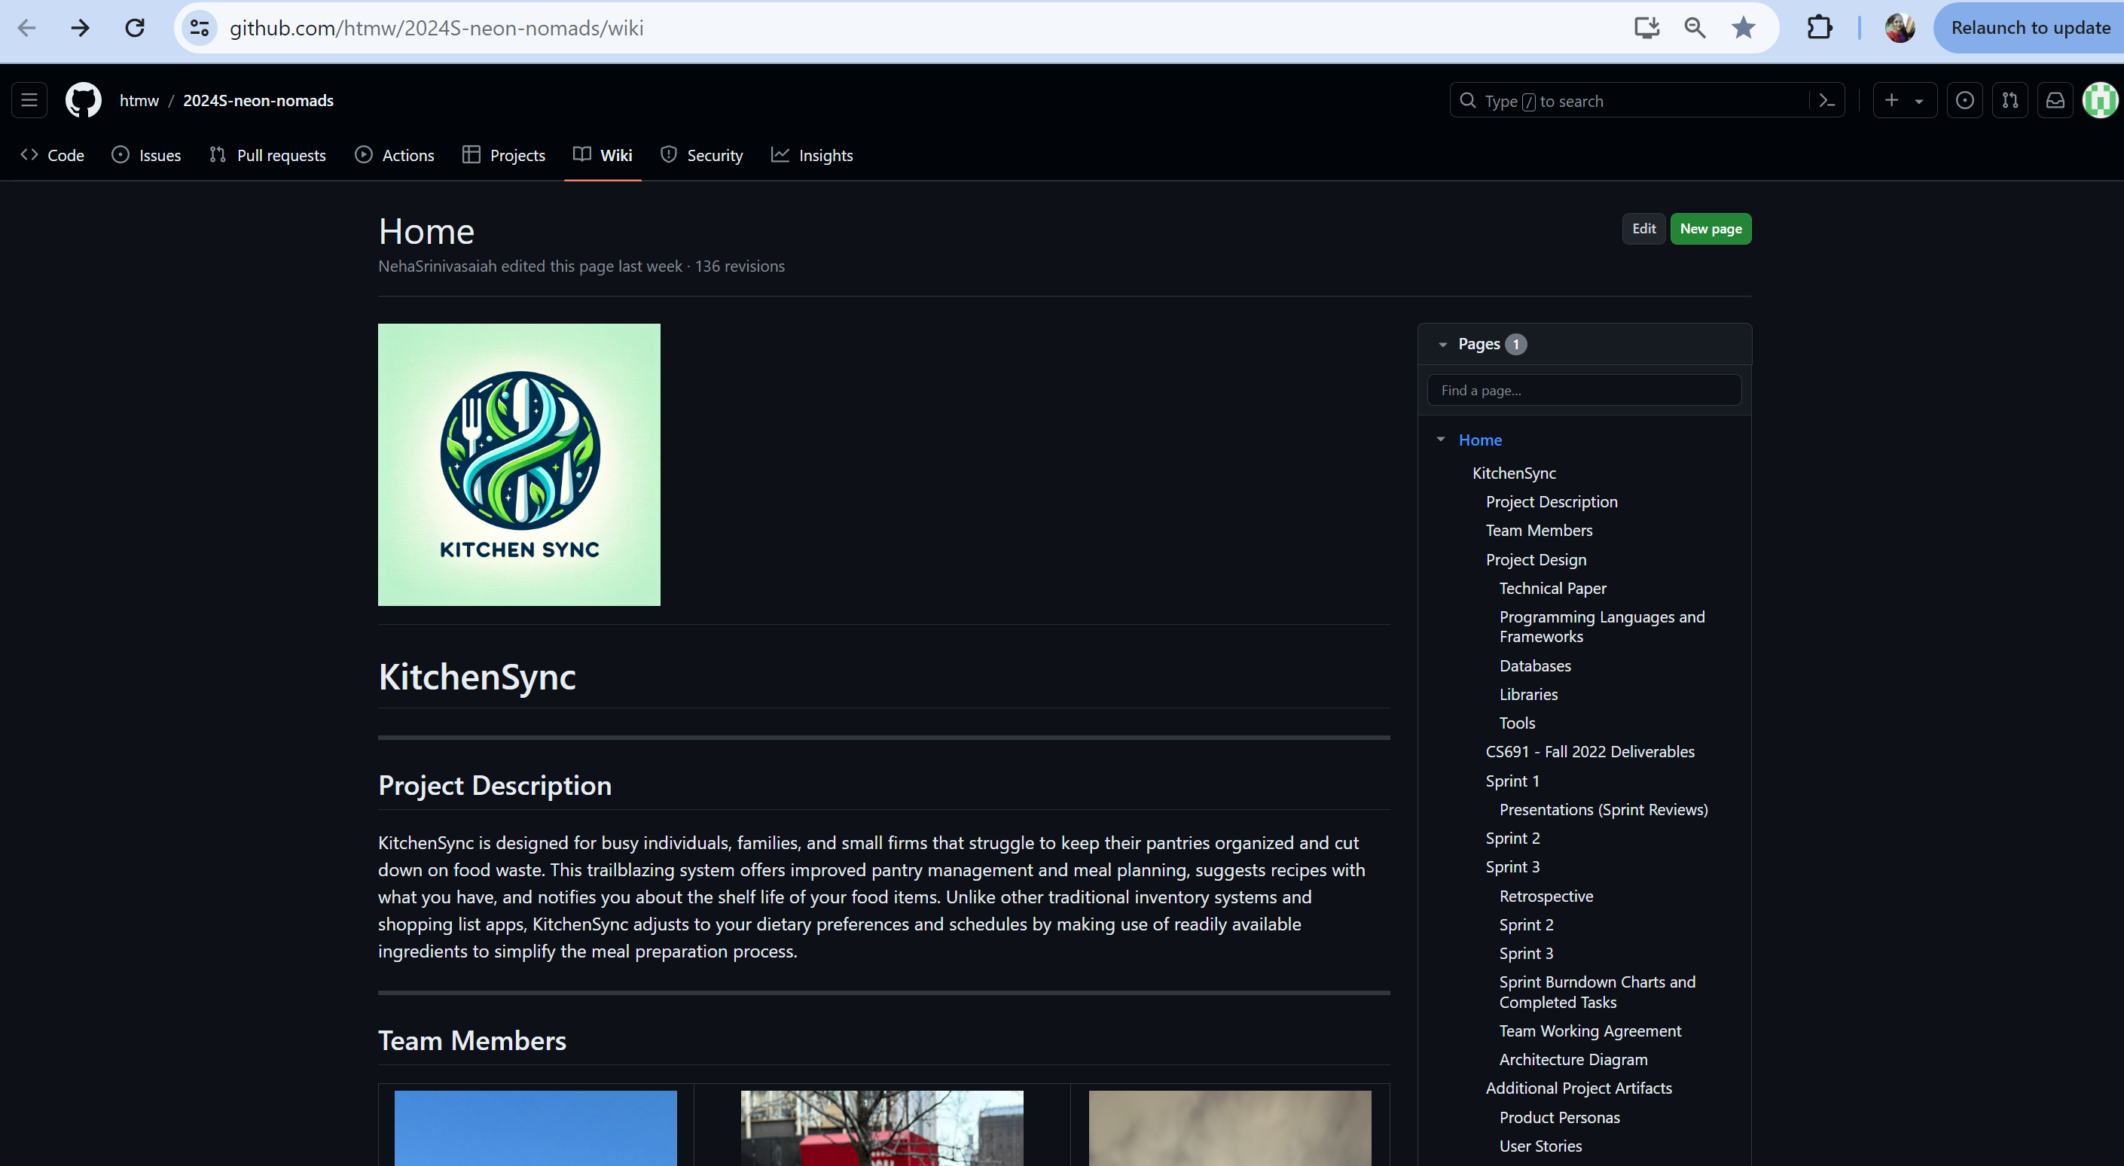

https://github.com/htmw/2024S-neon-nomads/wiki

This is the Link to Our GitHub Wiki Page. The user can understand more about our KitchenSync Application from here. Here we have provided the User Manual to Comprehend each functionality and every feature of Our application and provided all the documents for a better understanding of each aspect of our application. Also, we have provided a Demo video of KitchenSync to Understand Step by step use of our application.